# **Task 4: Database Backup and Recovery**

**Objective:**

To demonstrate how to back up the MySQL database and restore it using MySQL commands in case of data loss or system failure.

## **Backup Process:**

We created a backup (copy) of the database using the following steps:

* Opened Command Prompt and went to the MySQL installation folder using:

**cd "C:\Program Files\MySQL\MySQL Server 8.0\bin"**

* Used the mysqldump command to export the database:

**mysqldump -u root -p EmployeeDB > "C:\Users\BHOOMI\Desktop\employee_backup.sql"**

* After entering the MySQL root password, a file named employee_backup.sql was created on the Desktop. This file contains the full database structure and data.

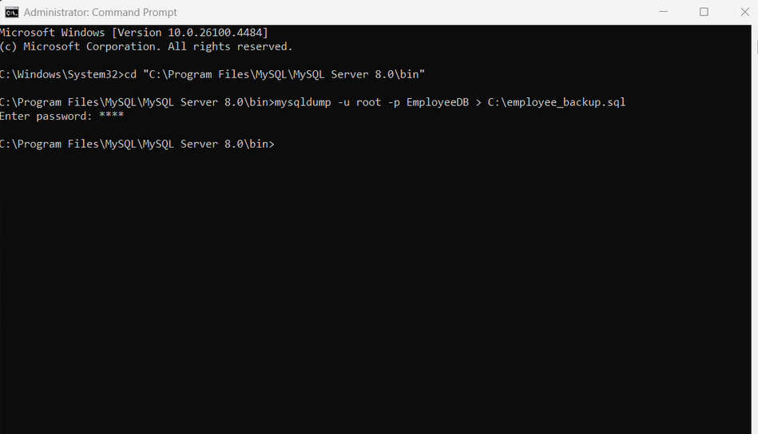

## **Recovery Process:**

We restored the backup into a new database using these steps:

* Opened Command Prompt and went to the same MySQL folder again:

**cd "C:\Program Files\MySQL\MySQL Server 8.0\bin"**

* Logged into the MySQL shell using:

**mysql -u root -p**

* Inside MySQL, created a new empty database to restore into:

**CREATE DATABASE EmployeeDB_Recovered;**

**EXIT;**

* Then ran this command to load the backup into the new database:

**mysql -u root -p EmployeeDB_Recovered < "C:\Users\BHOOMI\Desktop\employee_backup.sql"**

**Result:**

The database was successfully restored using the backup file.

All tables and records were successfully restored and verified in the new database EmployeeDB_Recovered.